**Rev. 01/2025**

**North American Lutheran Church**

**2113 Harwood 4703Road, Suite 309, PMB 409**

**Bedford, TX 76021-4703**

**North American Lutheran Church**

**2113 Harwood Road, Suite 309**

**PMB 409**

**Bedford, TX 76021-4703**

**11/2024**

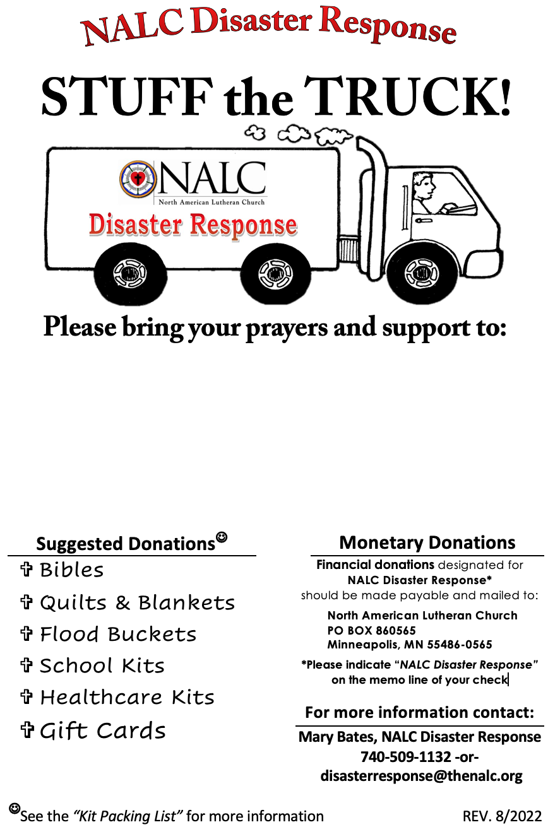

**Name of Church**

**Street Address**

**City, State**

**Date of Event**